BMIT2154: Switching And Routing Technologies (July 2024 semester) 
TUTORIAL 2: VLANs
1. Based on Figure 2.1, answer the following questions.
a) Provide Switch A configuration to fulfil the requirement as shown in Figure 2.1. 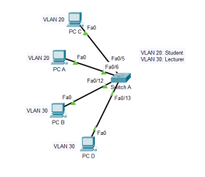
Figure 2.1 Network Topology

vlan 20
name Student

vlan 30
name Lecturer

interface range fa0/5 - 6 # int range fa0/5 - 6
switchport mode access # sw mo ac
switchport access vlan 20 # sw ac vlan 20

interface range fa0/12 - 13 # int range fa0/12 - 13
switchport mode access # sw mo ac
switchport access vlan 30 # sw ac vlan 30
b) Fill in the table to assign IP addresses for PC-A, PC-B, PC-C and PC-D based on the proposed network address for both VLAN 20 and VLAN 30.
VLAN | Network Address with Prefix | PC | IP Address with Prefix
20 | 192.168.20.0/24 | PC-C | 192.168.20.10/24
20 | 192.168.20.0/24 | PC-A | 192.168.20.11/24
30 | 192.168.30.0/24 | PC-B | 192.168.30.10/24
30 | 192.168.30.0/24 | PC-D | 192.168.30.11/24
* Can be other acceptable answer as long as all the pc within each vlan has the same subnet and correct subnet mask.

c) Explain TWO (2) benefits to configure the network with 2 VLANs.

- Smaller broadcast domains
  - Dividing the LAN reduces the number of broadcast domains
- Improved security
  - Only users in the same VLAN can communicate togethers.
- Improved IT efficiency
  - VLANs can group devices with similar requirements.
- Reduced cost
  - One switch can support multiple groups or VLANs.

Other answers:
- Enhanced network security: VLANs isolate traffic between group, preventing unauthorized access and reducing attack surfaces.
2. Provide the VLAN configuration for interface Fa0/12 on SwitchA to allow both PCA and the VoIP Phone to access the LAN by referring to Figure 2.2.
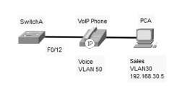
Figure 2.2 Network topology

vlan 30
name Sales

vlan 50
name Voice

interface fa0/12
switchport mode access
switchport access vlan 30 # for data
switchport voice vlan 50 # for voice [VoIP Phone (Cisco device) has two ports]
1
BMIT2154: Switching And Routing Technologies (July 2024 semester)
3. The IEEE 802.1Q standard specifies a native VLAN for trunk links, which defaults to VLAN 1. Explain the purpose of a native VLAN for trunk links.
- Native VLAN is used for untagged traffic on trunk links only.
- All frames are tagged on an 802.1Q trunk link except for those on the native VLAN.
- In IEEE 802.1Q, if a switch receives an untagged frame on a trunk port, it assumes the frame belongs to the native VLAN.
4. Explain Dynamic Trunking Protocol (DTP).
- Dynamic Trunking Protocol (DTP) is a proprietary Cisco protocol.
- Dynamic-auto is default on the 2960 and 2950 switches.
- It may be turned off with the nonegotiate command.
- It may be turned back on by setting the interface to dynamic-auto.
- Setting a switch to a static trunk or static access will avoid negotiation issues with switchport mode trunk or the switchport mode access commands.
5. Based on Figure 2.3, answer the following questions. Assume all the VLANs database have been created and access ports have been configured for relevant switches.
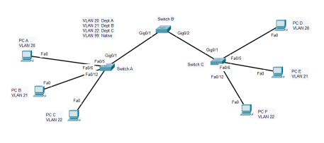Figure 2.3: Network Topology with VLANs
a) Why trunks need to be configured among all the three switches? Include the information from Figure 2.3 in your answer.
- Trunk links can help for passing multiple VLANs between switches using 802.1Q tagging, ensuring that VLANs can communicate across the entire network.
- It can also efficiently reduce the need for multiple physical links. Without trunks, we have to use a separate physical connection for each VLAN between switches.
- It can also avoid VLAN mismatch issues. Different switches might assign different VLANs to the same port number if only configuring access ports without trunking.

- Trunk links are required because multiple VLANs (20, 21, 22, 99) exist across Switch A, B and C.
- Switch B acts as a core switch, forwarding VLAN traffic between Switch A and Switch C.
- Without trunking, devices in different VLANs (e.g., PC-A in VLAN 20 and PC-D in VLAN22) would be isolated.
- Trunking ensures VLAN traffic can pass through the network while maintaining separation between VLANs.
b) Provide VLAN configuration for trunk links for Switch B using the following table to fulfil the requirement as shown in Figure 2.3. Configure the trunks at Switch B as static trunks. Allow the four VLANs to go through the trunk links. Configure VLAN 99 as the native VLAN.
Switch | VLAN Configuration
Switch B | Enable  Config terminal  Int g0/1 - 2  Switchport access mode trunk  Switchport trunk allowed vlan 20, 21, 22, 99  Switchport trunk native vlan 99

c) DTP is automatically enabled for Switch A and Switch C where switchport mode is dynamic auto. After Switch B has been configured based on the configuration done for Q5 b), will PC A able to ping PC D successfully? Will there be any syslog messages appear in all the three switches? Explain your answer.

- No, PC A is not able to ping PC D successfully because DTP is enabled on Switch A and Switch C. Their interfaces are in dynamic auto mode.
- In DTP, when both ends are in dynamic auto mode, they will stay as access ports instead of negotiating a trunk.
- Thus, no trunk link is being established.
- Since no trunk exists, VLAN 20 traffic from PC A would not be carried through Switch B to Switch C.
- Eventually, PC A will not be able to ping or reach PC D.

- Yes, PC A can successfully ping PC D because they have the same VLAN 20.
- Yes, both Switch A and Switch C will receive syslog messages stating that there is a Native VLAN mismatch.
- Although this is not affecting the communication between PC A and PC D.
- (VLAN 20), Native VLAN mismatch has to be resolved.
d) Based on your answer in Q5 c), provide VLAN configuration for trunk links for Switch A and Switch C using the following table. In addition, allow the four VLANs to go through the trunk links.
Switch | VLAN Configuration
Switch A | Enable  Config terminal  Int g0/1  Switchport trunk allowed vlan 20, 21, 22, 99  Switchport trunk native vlan 99
Switch C | Enable  Config terminal  Int g0/1  Switchport trunk allowed vlan 20, 21, 22, 99  Switchport trunk native vlan 99

2
BMIT2154: Switching And Routing Technologies (July 2024 semester)
e) Assume that the trunks that were configured in Q5 b) and Q5 d) need to be reset to default state, provide the configuration to do so. Only provide the configuration for one of the switches in your answer.

Enable
Configure terminal
Interface G0/1 - 2
No switchport trunk allowed vlan
No switchport trunk native vlan
6. Source: Modified from Past Year Question 8 June 2023.
Refer to Figure 2.4 shown below, interfaces Gi0/1 and Gi0/2 are missing from the output of the ‘show vlan brief’ command. Why?
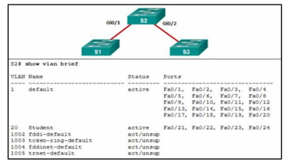Figure 2.4: Network Topology
- The interfaces Gi0/1 and Gi0/2 are set as trunk ports.
- Trunk ports are not shown in this command output because they are not assigned to a single VLAN; instead, they carry multiple VLANs.
7. Figure 2.5 shows a VLAN table captured on 1st July 2020 of a fixed form-factor switch S1 with 24-port Fast Ethernet and 2-port Gigabit Ethernet. A junior network administrator had done some configurations in Switch S1 on 2nd July 2020 and the VLAN table is shown in Figure 2.6.
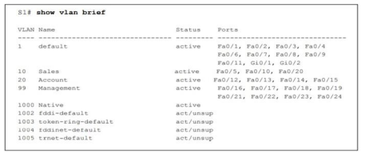Figure 2.5: Output of Switch S1 captured on 1st July 2020
3
BMIT2154: Switching And Routing Technologies (July 2024 semester) 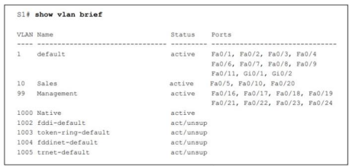
Figure 2.6: Output of Switch S1 captured on 2nd July 2020
Examine Figure 2.5 and Figure 2.6. Comment on this output. Suggest the correct ways so that the missing ports return to the default VLAN.
- The VLAN 20 has been removed from S1 and any port which is assigned to VLAN 20 will become inactive. Thus, the VLAN and its associated ports will also not be shown in the “show vlan brief” command output list.
- However, the missing ports still exist physically.
- In order to return the missing ports to the default VLAN, we should use the command:
  - Interface g0/12 - 15
  - No switchport access vlan
- Eventually, all the missing ports will be returned back to the VLAN 1 which is the default VLAN.
8. During the configuration of a fixed form factor switch with 24 Fast Ethernet and 2 Gigabit Ethernet ports, you noticed the VLAN table of this switch shows the following listing.
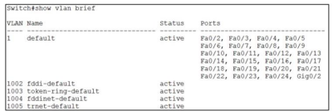Figure 2.7: A VLAN table
Illustrate TWO (2) possible conclusions that you can obtain from the listing of the VLAN table shown in Figure 2.7.
- All interfaces are in the default VLAN which is VLAN 1 except Gig0/1 because all the fast ethernet from Fa0/2 - 24 and GigabitEthernet Gig0/2 are assigned to VLAN 1.
- The GigabitEthernet Gig0/1 interface has been assigned as the trunk port because it is not shown in the VLAN list.

- 1st possibility: These ports may be configured as trunk ports. This is because trunk ports are not listed in the VLAN table.
- 2nd possibility: A VLAN where these 2 ports have been assigned to has database before reassign these ports to another VLAN.
4

